



FACULTY OF ENGINEERING &
TECHNOLOGY
DEP.MECHATRONICS

Smart Greenhouse Monitoring System Based On IOT
18EC62: Implementation of IOT applications using packet tracer

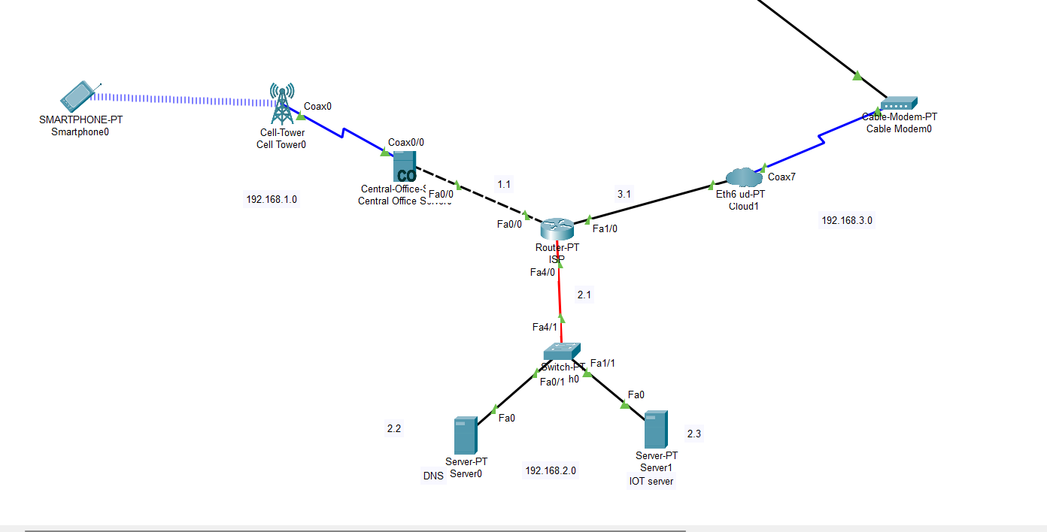

Supervision\
Eng. Saeed Al-Sama’i

Prepared by:
AL-Bara’a Amir AL-Zofi

Figure No. | Caption / Description
Fig 1 | Block Diagram of Smart Greenhouse IoT System
Fig 2 | Smartphone Monitoring Interface
Fig 3 | System Decision Logic Flowchart
Fig 4 | Temperature Monitoring System Setup
Fig 5 | Humidity Monitoring System Setup
Fig 6 | Fire Safety & Smoke Detection System
Fig 7 | CO2 Detection System & Exhaust Fan Control
Fig 8 | Soil Moisture Monitoring & Irrigation System
Fig 9 | Solar Cell Power Supply & Battery System
Fig 10 | Smart Door Access Control System (RFID & Siren)
Fig 11 | Smart Light Control System
Fig 12 | Overall Network Topology in Cisco Packet Tracer
Fig 13 | Assigning IP Address to Central Office Server
Fig 14 | Assigning IP Address to IoT Server
Fig 15 | Assigning IP Address to DNS Server

Abstract:
This report presents an engineering project for a smart greenhouse monitoring system that leverages Internet of Things (IoT) technologies to enhance plant growth and simplify management. The system was designed using Cisco Packet Tracer software to simulate an integrated network of sensors that measure temperature, humidity, and carbon dioxide levels, as well as fire safety systems. The report details the operation of smart actuators that automatically respond to environmental conditions, such as activating sprinklers or fans based on predefined values. It also covers the technical aspects of networking, including assigning IP addresses to servers and controlling lighting and doors via smartphones. This design aims to replace traditional manual monitoring with a fully automated environment that efficiently boosts agricultural productivity. The report concludes with a review of the flowcharts and communication protocols necessary to ensure the stable performance of advanced greenhouses.

S.NO | CONTENT | Page No
1 | Title of the project | 1
2 | Abstract | 2
3 | List of Figures | 3
4 | Introduction | 5
5 | Methodology/approach | 5
6 | Flow chart | 13
7 | Connections and assigning IP address | 14
8 | Conclusion | 16
9 | References | 16
10 | Appendix | 17

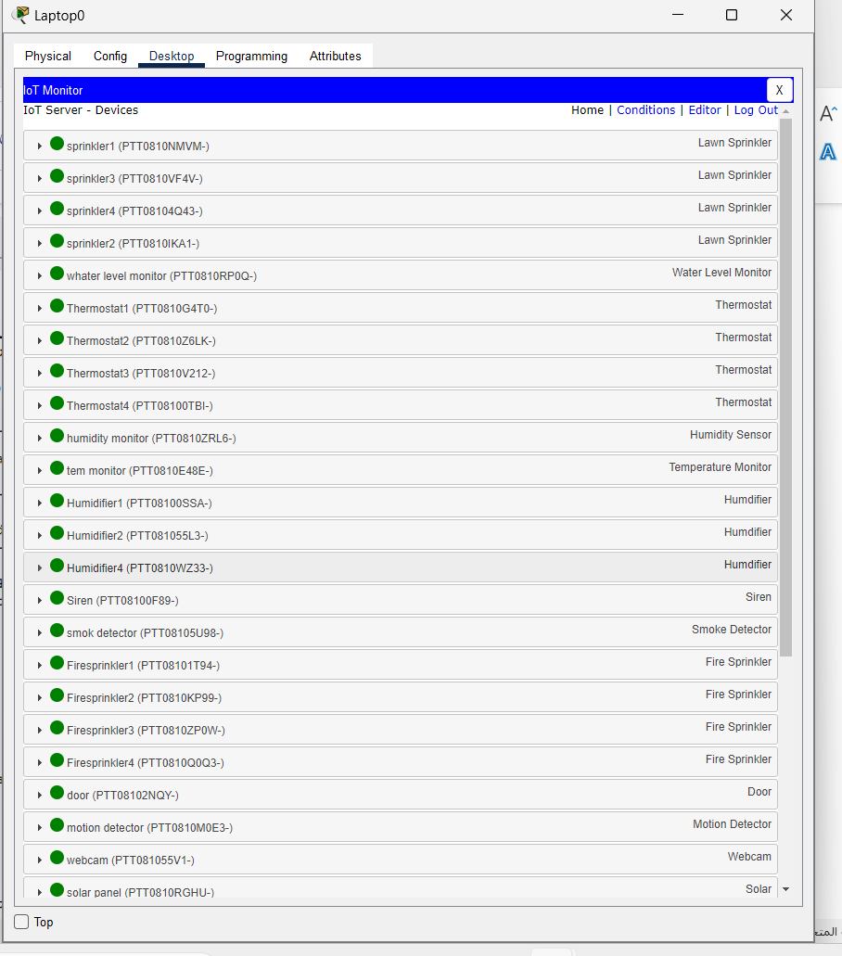
Appendix:


